Lab 11

GUI Graphics and Diagrams

1. GUI Programming (10 points)

Run and review kiloconverter.java. Then answer the following questions:

* 1. What is the window title?

**- Kilometer Converter**

1.2. What type of object is calcButton?

**- JButton**

1.3. What is the name of the JPanel variable in buildPanel?

**- Panel**

1.4. What three components get added to the panel?

**- A JLabel, JTextField and JButton**

1.5. How does the program show its results: a message dialog, or on the console?

**- Message dialog**

1.6. What variable is kiloTextField.getText() assigned to?

**- input**

1.7. What method is used to convert the input string to a Double?

**- actionPerformed()**

1.8. What method gets called to display the window? (What method makes the window visible?)

**- setVisible()**

1.9. What class does KiloConverter extend?

**- JFrame**

1.10. What interface does calcButtonListener implement?

**- ActionListener**

2. Graphics (20 points)

Adapt the LinesDemo to write your first name in lines on the screen. If your first name is more than eight characters, feel free to use a short version, a nickname, or just draw the first five letters.

Rubric:  
Student name and today’s date is a comment in the first line of the programs: -5 points if fails  
Screenshot and program code: -5 points if fails  
Name written in lines: 20 points

Please paste a screenshot of a successful program run, and copy-and-paste the source code from your main program's .java file, here.

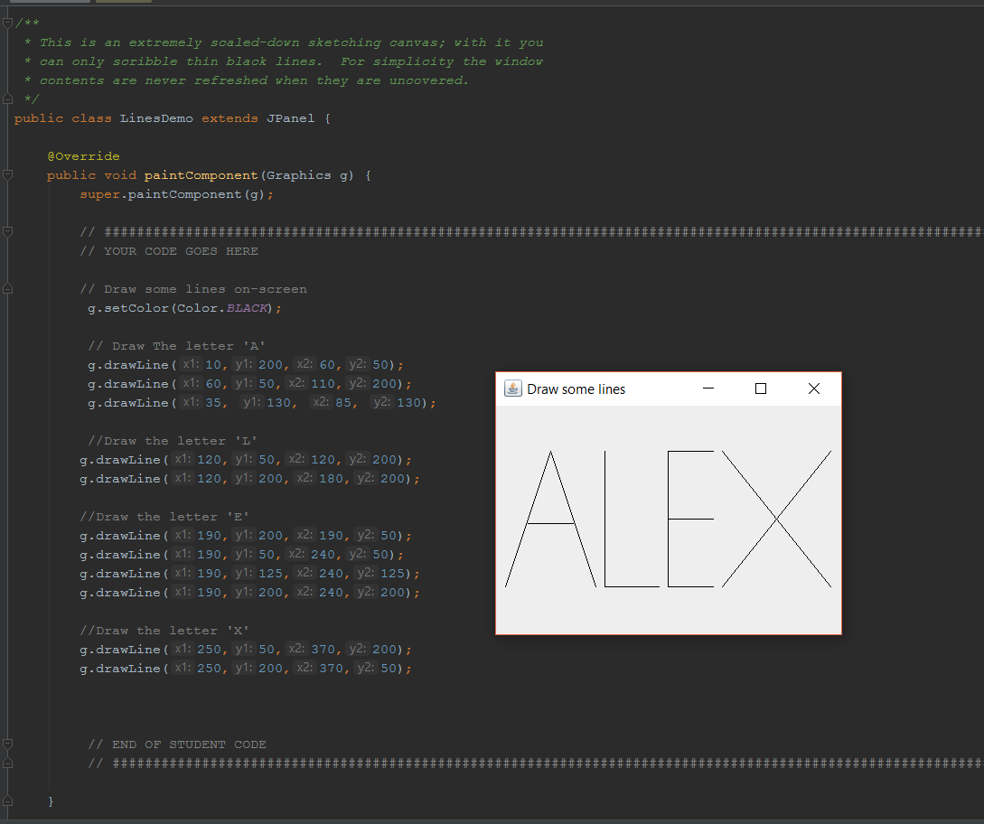

**LinesDemo.java:**

//Alex Bledsoe, 06/09/2017  
  
// Code from http://cs.lmu.edu/~ray/notes/javagraphics/   
// and https://stackoverflow.com/questions/16206417/trying-to-draw-lines-with-jpanel  
  
import java.awt.Color;  
import java.awt.Graphics;  
  
import javax.swing.*;  
  
*/**  
 * This is an extremely scaled-down sketching canvas; with it you  
 * can only scribble thin black lines. For simplicity the window  
 * contents are never refreshed when they are uncovered.  
 */*public class LinesDemo extends JPanel {  
   
 @Override  
 public void paintComponent(Graphics g) {  
 super.paintComponent(g);  
   
 // ############################################################################################################################  
 // YOUR CODE GOES HERE  
   
 // Draw some lines on-screen  
 g.setColor(Color.*BLACK*);  
   
 // Draw The letter 'A'  
 g.drawLine(10,200,60,50);  
 g.drawLine(60,50,110,200);  
 g.drawLine(35, 130, 85, 130);  
  
 //Draw the letter 'L'  
 g.drawLine(120,50,120,200);  
 g.drawLine(120,200,180,200);  
  
 //Draw the letter 'E'  
 g.drawLine(190,200,190,50);  
 g.drawLine(190,50,240,50);  
 g.drawLine(190,125,240,125);  
 g.drawLine(190,200,240,200);  
  
 //Draw the letter 'X'  
 g.drawLine(250,50,370,200);  
 g.drawLine(250,200,370,50);  
   
   
   
 // END OF STUDENT CODE  
 // ############################################################################################################################  
   
 }  
  
 */**  
 * A tester method that embeds the panel in a frame so you can  
 * run it as an application.  
 */* public static void main(String[] args) {  
 // 1. Create a Window  
 JFrame frame = new JFrame("Draw some lines");   
 frame.setDefaultCloseOperation(WindowConstants.*EXIT_ON_CLOSE*);  
 frame.setSize(400, 300);  
 frame.setVisible(true);  
   
 // 4. Put a panel on the window  
 frame.add(new LinesDemo());  
 }  
}

3. Use Case and Sequence Diagrams (Questions, 15 points)

Review the following diagrams and answer the questions below.

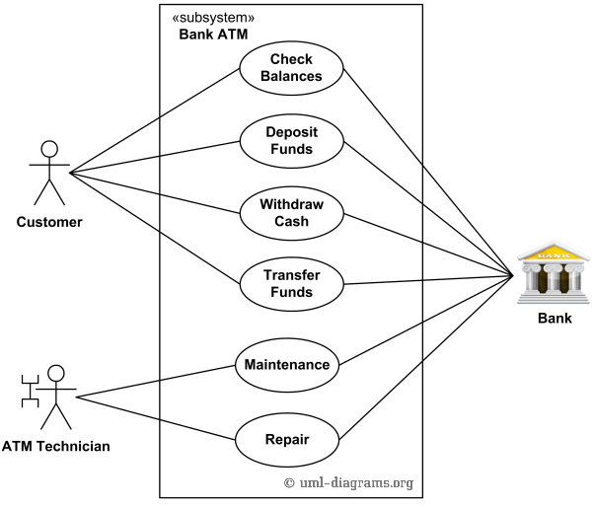

Thanks to: <http://www.uml-diagrams.org/bank-atm-uml-use-case-diagram-example.html>

3.1. What are the three actors in this use case diagram? (Hint: the bank is also an actor)

**- Customer, ATM Machine and Bank.**

3.2. What six actions are captured in this diagram?

**- Check Balances, Deposit Funds, Withdraw Cash, Transfer Funds, Maintenance, and Repair.**

3.3. What system is being modeled?

**- A banking system.**

3.4. Can an ATM technician transfer funds?

**- No.**

3.5. Can a customer transfer funds?

**- Yes.**

3.6. Can the bank transfer funds?

**- Yes.**

3.7. Which actors are involved in checking balances?

**- The Customer and the Bank.**

3.8. If a customer checks their account balance, is the ATM technician involved?

**- No.**

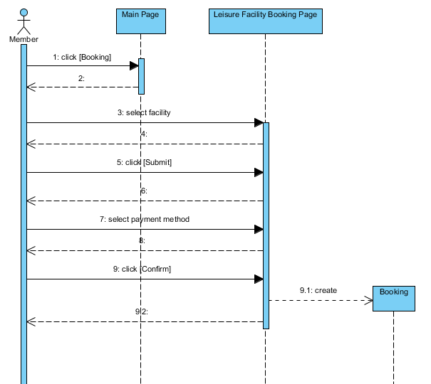

Thanks to: <https://www.visual-paradigm.com/VPGallery/diagrams/Sequence.html>

3.9. How can you tell that the click for booking happens first?

**- It’s a sequence diagram and interactions are arranged from top to bottom.**

3.10. Why does the customer have to click "booking" before they can select a facility?

**- They may be going to the main page for another reason (i.e. looking for contact info).**

3.11. Which action happens later: select payment method, or the step 9.2 response from the booking page?

**- 9.2 response.**

3.12. Which action happens later: click to submit, or the booking being created?

**- The booking being created.**

3.13. How many interactions are expected on the main page? (Hint: how many arrows go to/from it?)

**- 2.**

3.14. How many interactions are expected with the booking database?

**- 1.**

3.15. How many **responses** are expected from the leisure facility booking page? (Hint: how many arrows go from it to the member?)

**- 4.**